Comp307 Assignment #4

Student Name

Student Id

Installing DVWA

1. Download the files:
   1. XAMPP (xampp-portable-win32-7.1.8-0-VC14-installer)
   2. DVWA
2. Extract XAMPP and DVWA in a fast drive (don’t use the H: drive or a slow USB drive):
3. Copy XAMPP to the C: drive

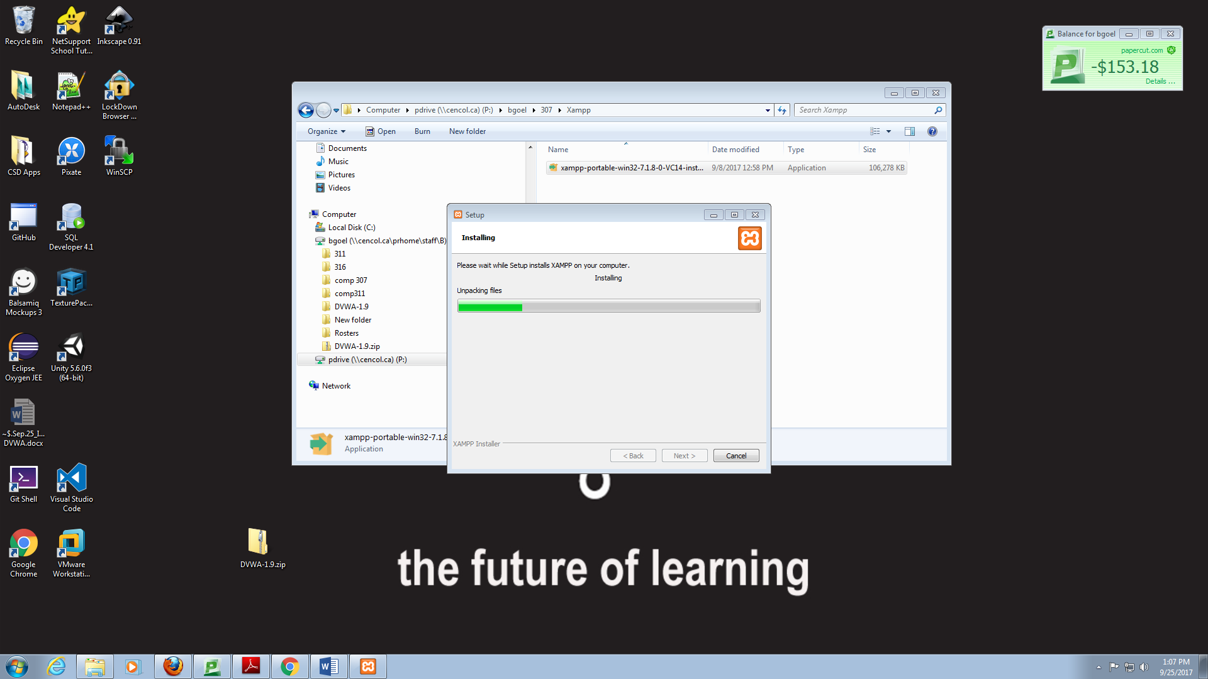

1. Wait until you see this:
2. Click Enter. Click xampp-control.exe. You will see this: 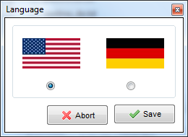
3. Click Save. You will see this:

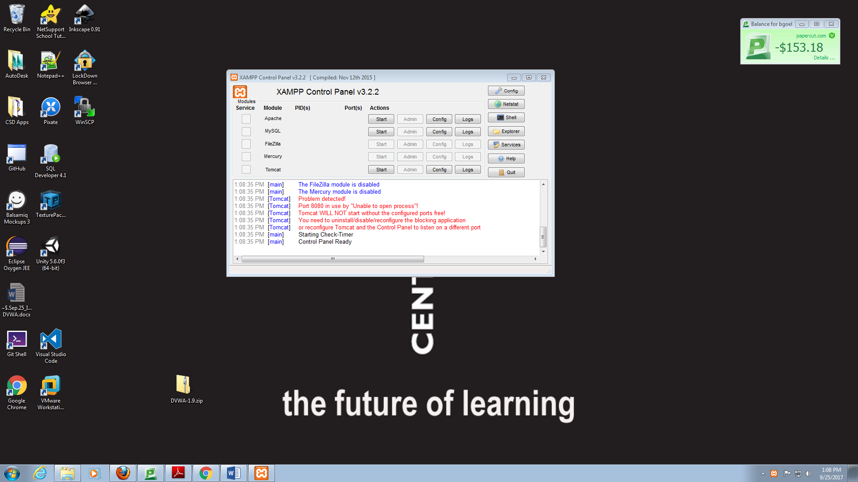

1. The text in red might vary. Notice the line ‘Port 80….’.
2. **Starting Apache.** Click ‘Start’ on the Apache line. Either Apacheweb server starts (indicated by a green backbround; go to **Starting MySQL** step) or you get some red lines. In this click the ‘Config’ botton in the Apache line. You will see this: 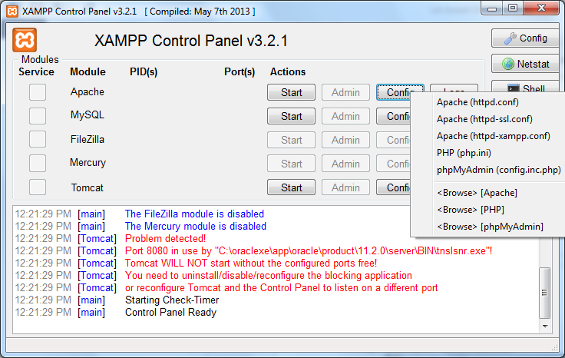
3. **Change the line:** *Listen 80* To ***Listen 8081***
4. **Change the line:** *ServerName localhost:80* **to *ServerName localhost:8081***
5. **Close notpad**
6. Start Apache. You will eventually see this:
7. **Start MySQL**.
8. **Copy DVWA folder into htdocs**

